Bike Share Ride - Data Analysis
- Ask - Project Objective: Identify the difference between casual and membership riders. This objective will help the business increase membership rides by attracting casual riders.
Dataset: Bike_Share
Source: Cyclistic / Divvy public dataset
Period: 202101 - 202105
Tools used: Google BigQuery, SQL, Tableau
- Prepare – Data Collection: Joined all the tables with the “UNION ALL” command and created a new table.
CREATE TABLE `data-analysis-project-487214.Bike_share.Bike_Share_2021` AS
SELECT *
FROM `data-analysis-project-487214.Bike_share.Bike_share_202101`
UNION ALL
SELECT *
FROM `data-analysis-project-487214.Bike_share.Bike_share_202102`
UNION ALL
SELECT *
FROM `data-analysis-project-487214.Bike_share.Bike_Share_202103`
UNION ALL
SELECT *
FROM `data-analysis-project-487214.Bike_share.Bike_Share_202104`
UNION ALL
SELECT *
FROM `data-analysis-project-487214.Bike_share.Bike_Share_202105`;
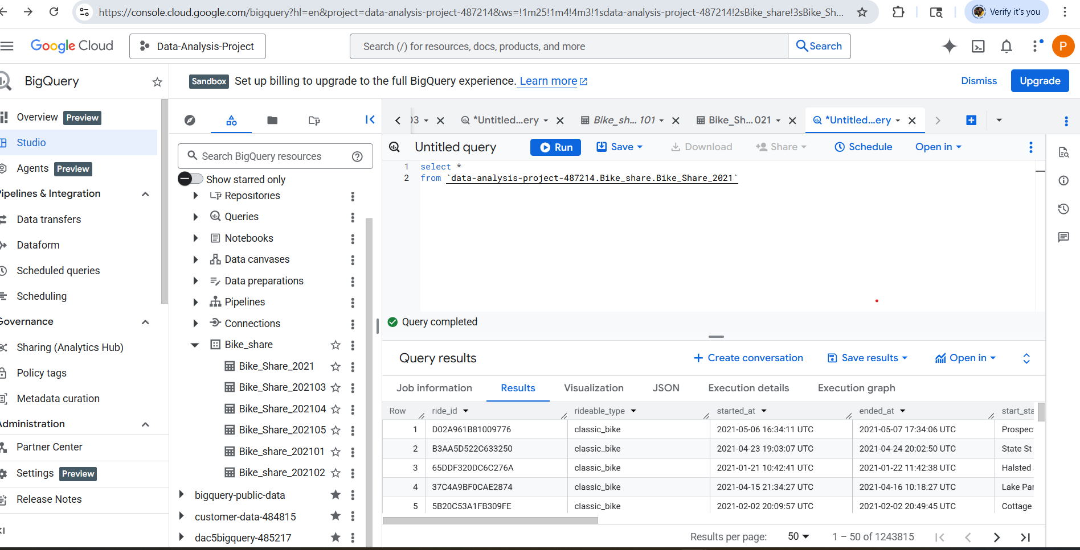
- Process – Data Cleaning:
Check for duplicates.
SELECT ride_id, COUNT(*)
FROM `data-analysis-project-487214.Bike_share.Bike_Share_2021`
GROUP BY ride_id
HAVING COUNT(*) > 1;
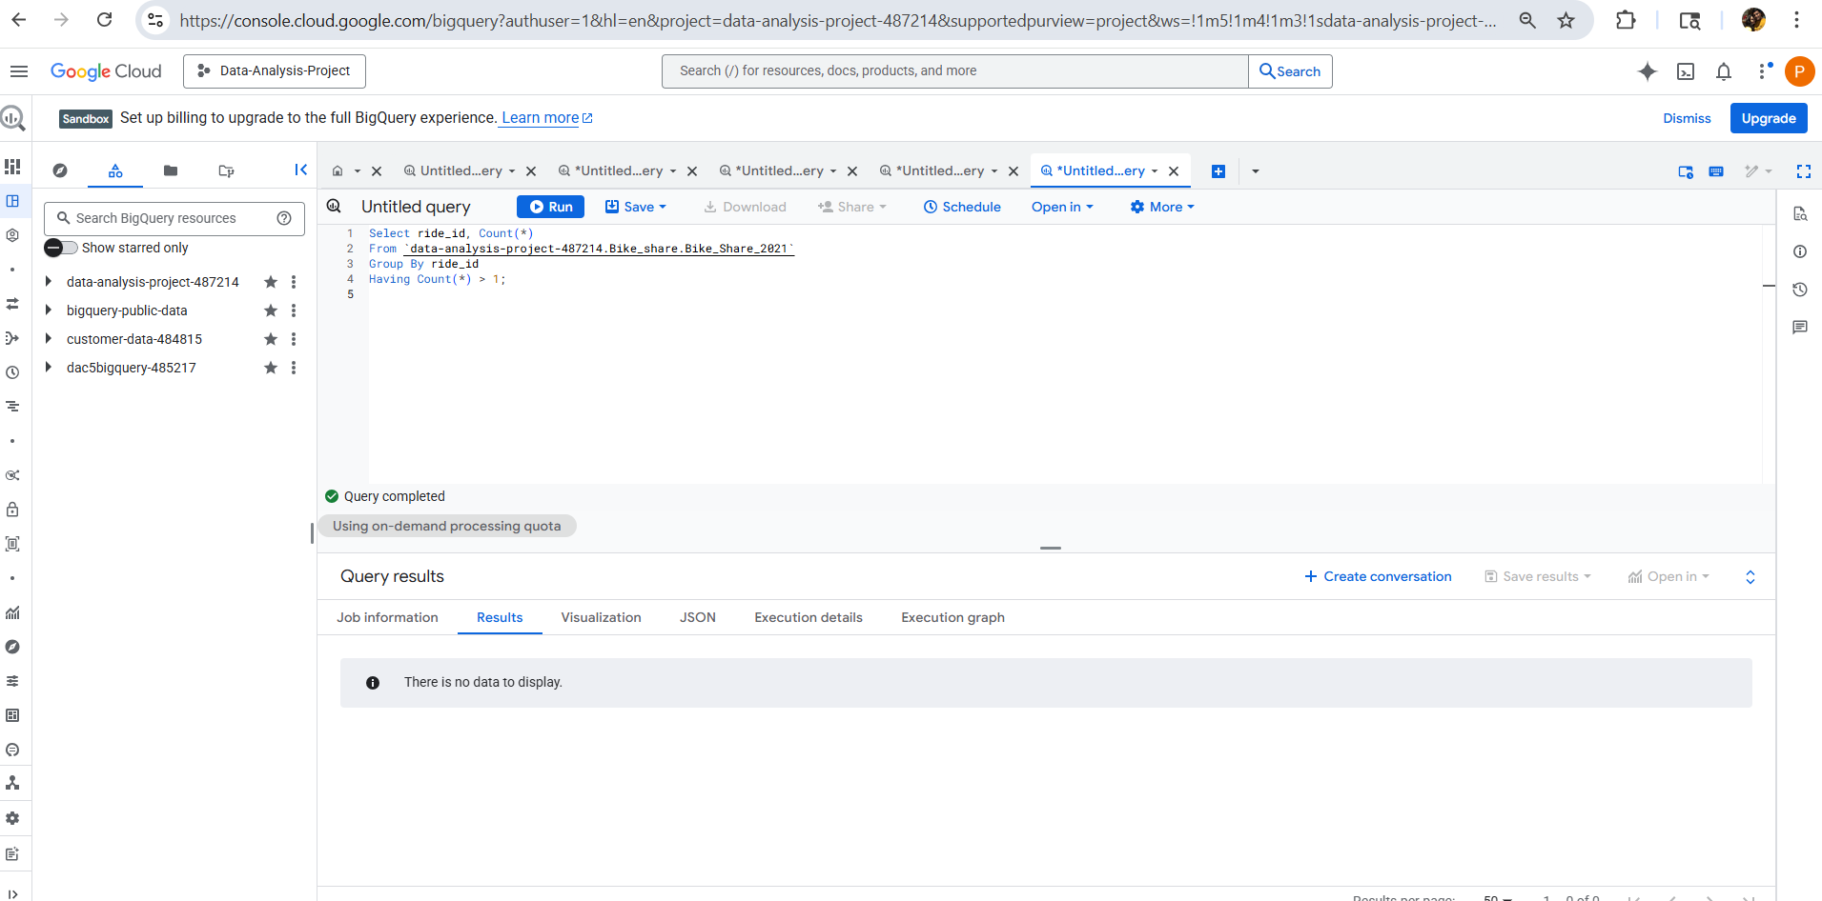
There are no duplicate ride_ids.
Remove null values.
SELECT COUNT(*)
FROM `data-analysis-project-487214.Bike_share.Bike_Share_2021`
WHERE start_station_id IS NULL
OR end_station_id IS NULL;

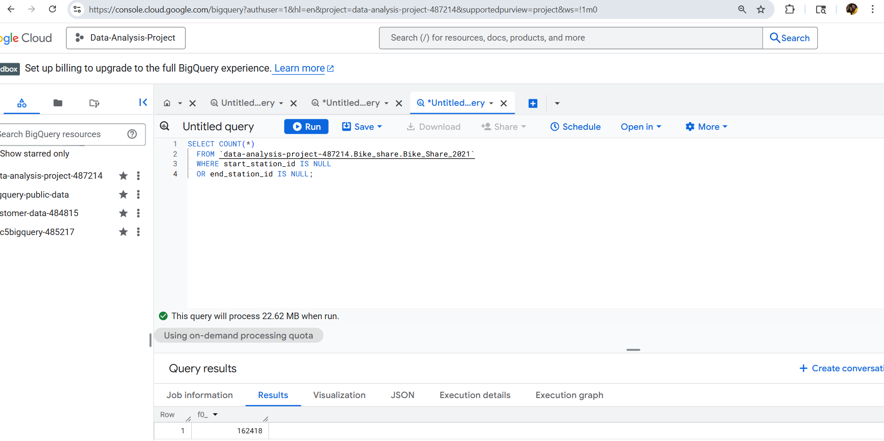
Missing start id or end id count = 162418
Create a new table without null values in start_station_id and end_station_id.
CREATE TABLE `data-analysis-project 487214.Bike_share.Bike_Share_2021_removed_null_values` AS
SELECT *
FROM `data-analysis-project-487214.Bike_share.Bike_Share_2021`
WHERE start_station_id IS NOT NULL
AND end_station_id IS NOT NULL;
Rename the start_at and end_at columns to more meaningful names, starting_time and ending_time.
ALTER TABLE `data-analysis-project-487214.Bike_share.Bike_Share_2021_removed_null_values`
RENAME COLUMN started_at TO starting_time;

ALTER TABLE `data-analysis-project-487214.Bike_share.Bike_Share_2021_removed_null_values`
RENAME COLUMN ended_at TO ending_time;

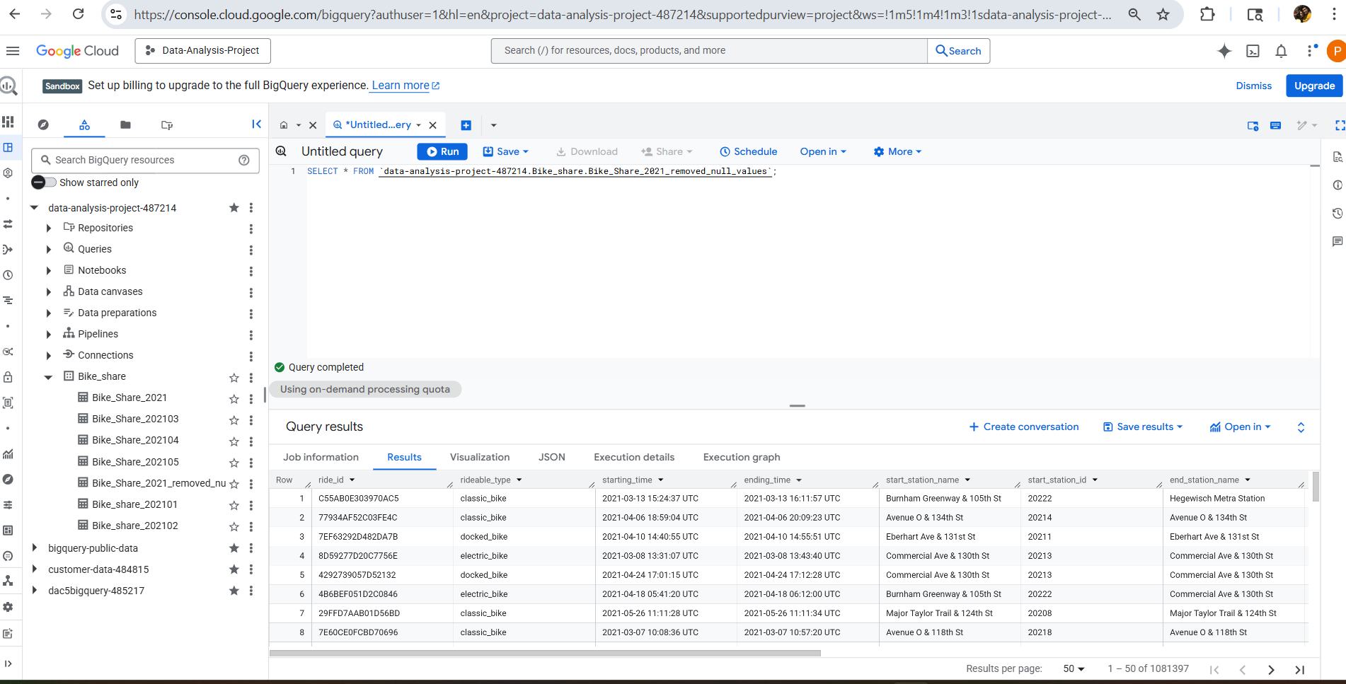
- Analyze – Data Exploration
- Ride Type:
Calculate casual and membership rides.
SELECT member_casual, COUNT(*) AS total_trips
FROM `data-analysis-project-487214.Bike_share.Bike_Share_2021`
WHERE start_station_id IS NOT NULL
AND end_station_id IS NOT NULL
GROUP BY member_casual;

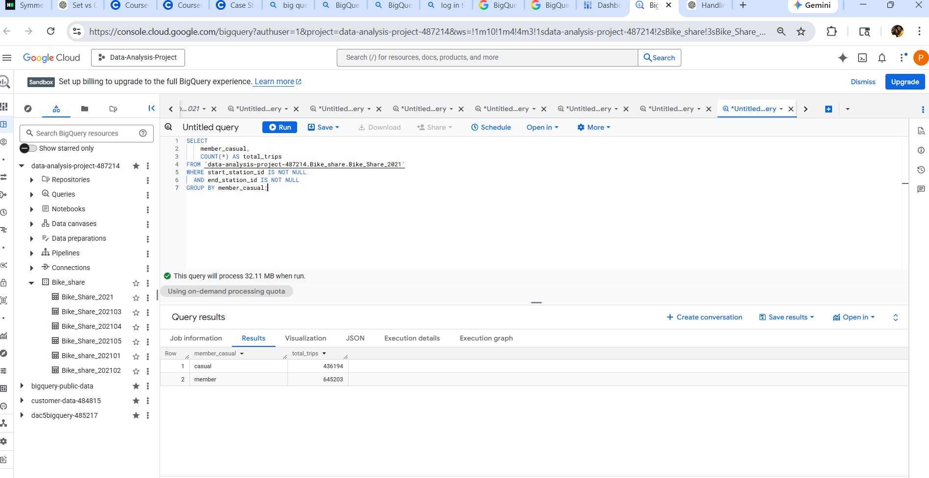
Casual riders = 436194
Membership riders = 645203
- Bike Type:
There are three types of bikes available: Classic, Docked, and Electric.
SELECT rideable_type, COUNT(*) AS rideable_count
FROM `data-analysis-project-487214.Bike_share.Bike_Share_2021`
GROUP BY rideable_type
ORDER BY rideable_count DESC
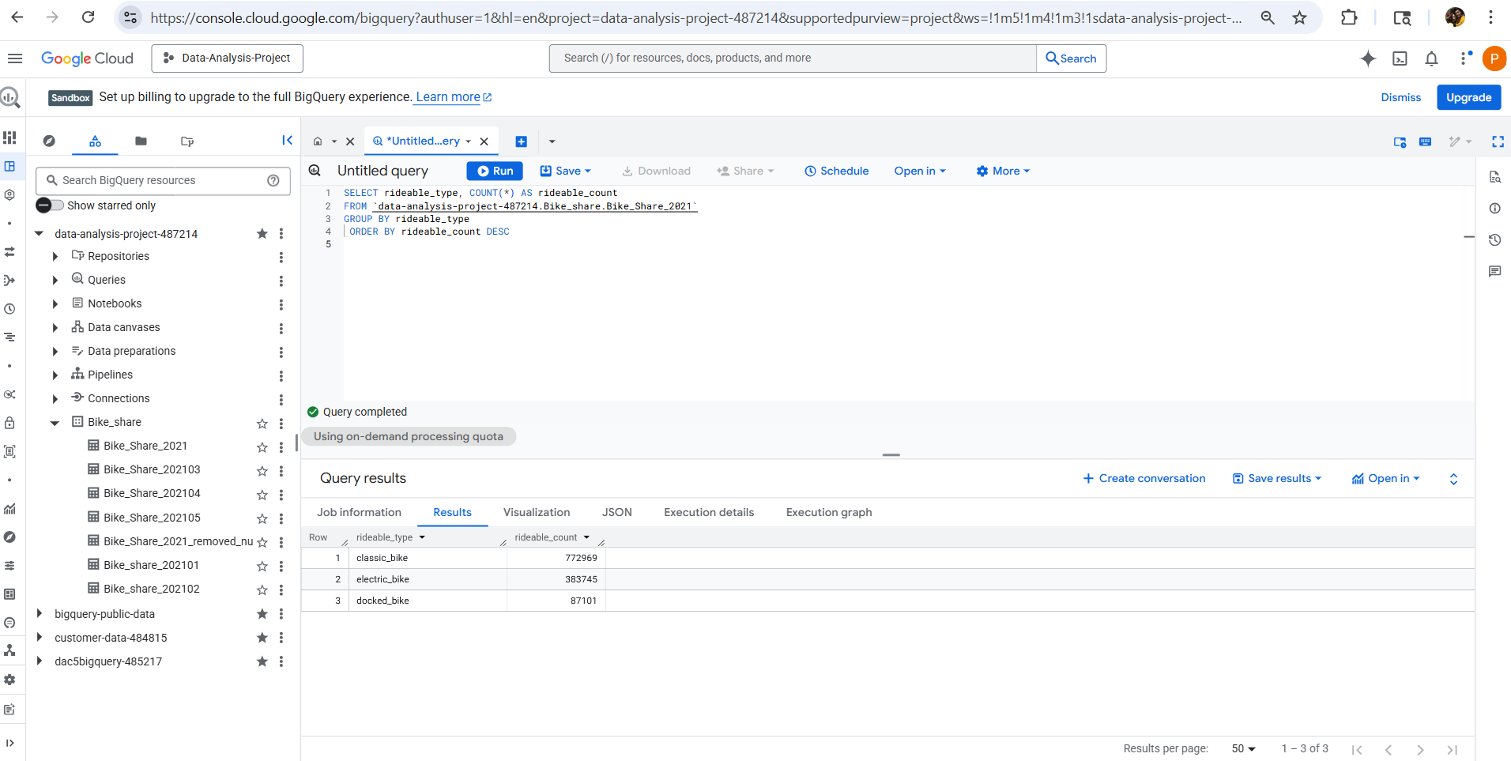
Classic bike usage is higher than that of other bikes.
Classic bike = 772969
Electric bike = 383745
Docked bike = 87101
- Ride Day:
Analyzes weekday and weekend rides for casual and membership rides.
SELECT member_casual,
CASE WHEN EXTRACT(DAYOFWEEK FROM starting_time) IN (1, 7) THEN 'Weekend'
ELSE 'Weekday'
END AS day_type,
COUNT(*) AS total_rides
FROM `data-analysis-project-487214.Bike_share.Bike_Share_2021_removed_null_values`
GROUP BY member_casual, day_type
ORDER BY member_casual, day_type;

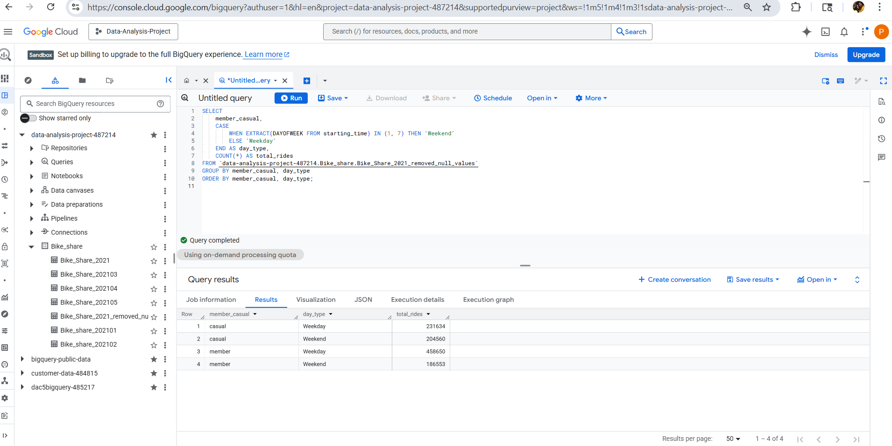
Weekdays have more rides than weekend rides for both casual and membership rides.
- Ride Length:
Calculate the ride length in minutes, which is less than one day, less than one week, less than one month, and greater than one month. Group the casual, and the member count in each category.
SELECT member_casual,
CASE WHEN TIMESTAMP_DIFF(ending_time, starting_time, MINUTE) < 1440
THEN 'Less than 1 day'
WHEN TIMESTAMP_DIFF(ending_time, starting_time, MINUTE) < 10080
THEN '1 to 7 days'
WHEN TIMESTAMP_DIFF(ending_time, starting_time, MINUTE) < 40320
THEN '7 to 28 days'
ELSE 'More than 28 days'
END AS ride_duration_category,
COUNT(*) AS total_rides
FROM `data-analysis-project-487214.Bike_share.Bike_Share_2021_removed_null_values`
GROUP BY member_casual, ride_duration_category
ORDER BY member_casual, total_rides DESC;
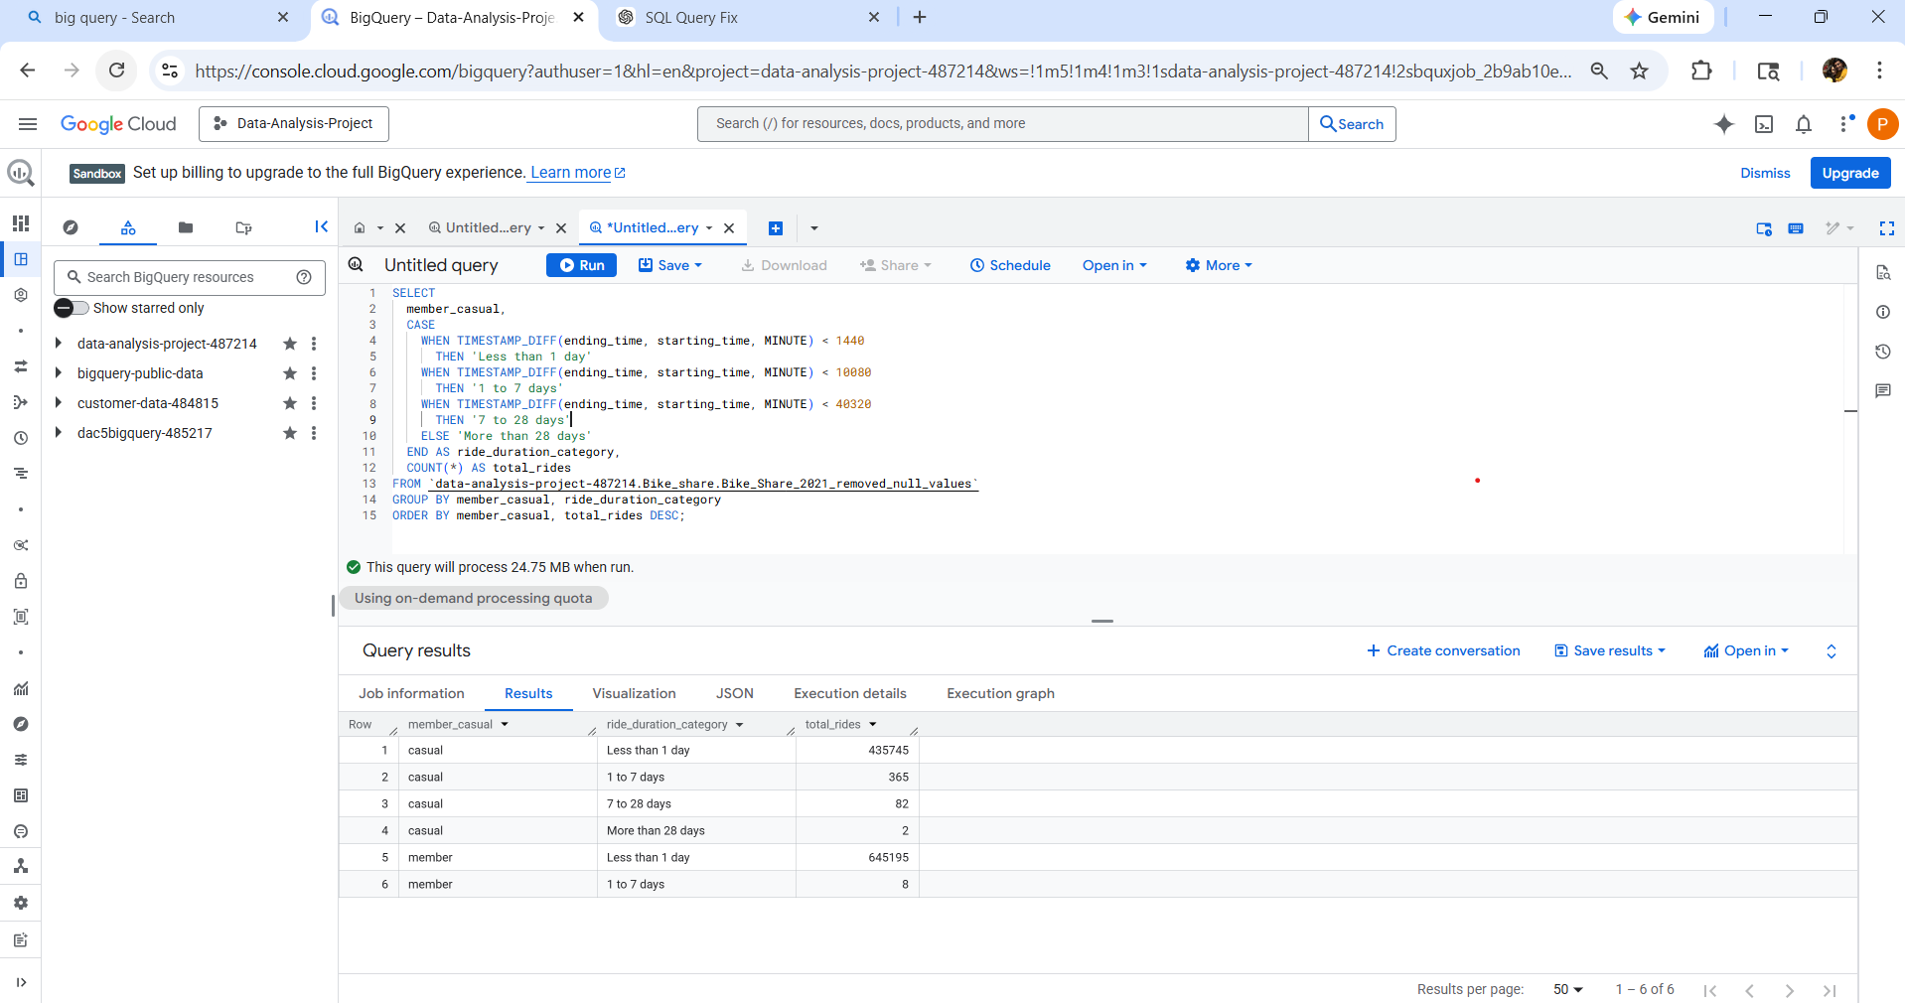

- Share – Visualization
Ride Type:
Member rides count considerably higher than the casual rides.
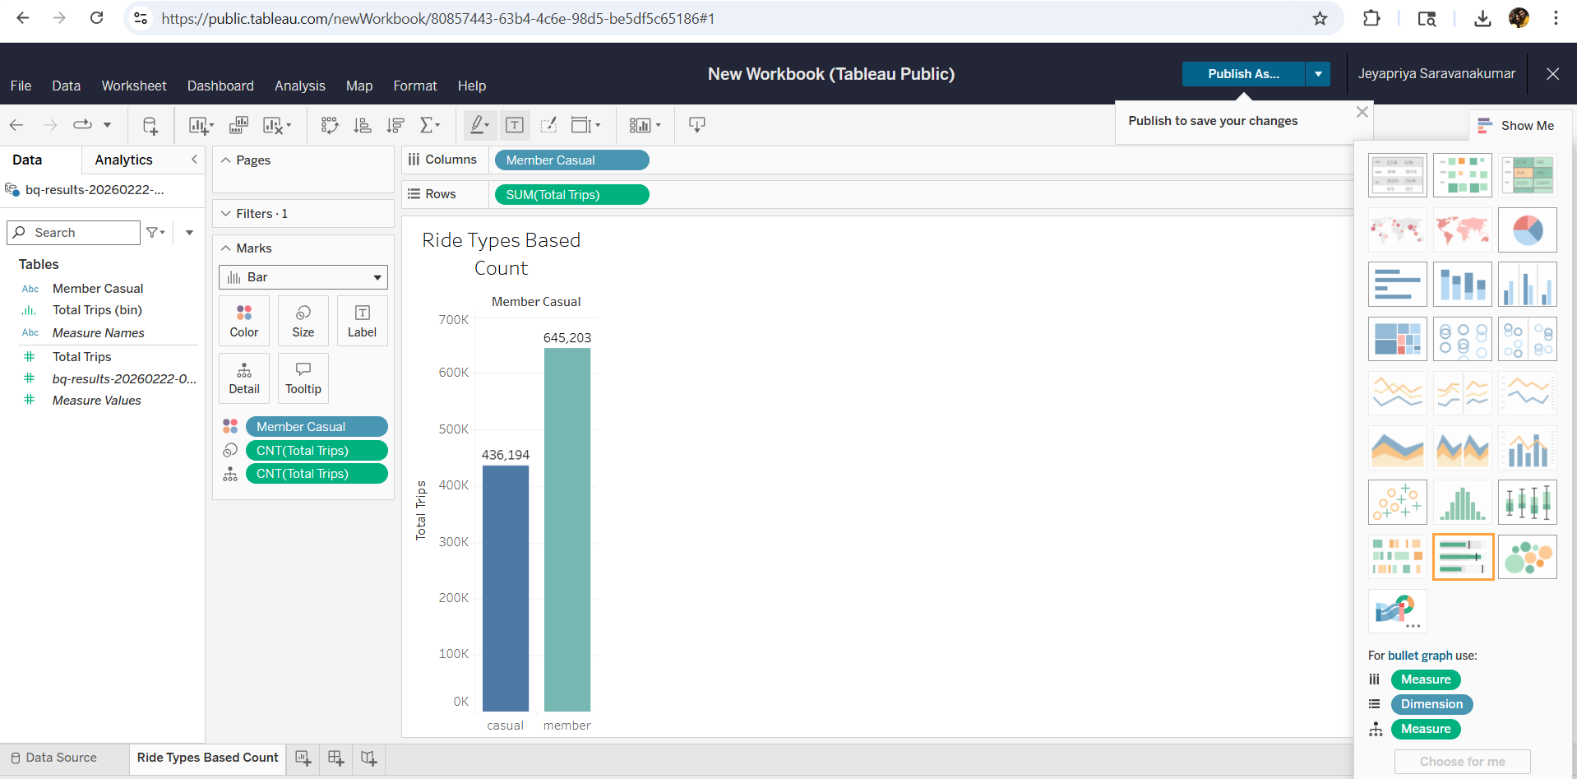
Bike Type:
This visualization clearly shows that classic bikes are used more than other bikes, and docked bikes are used less.
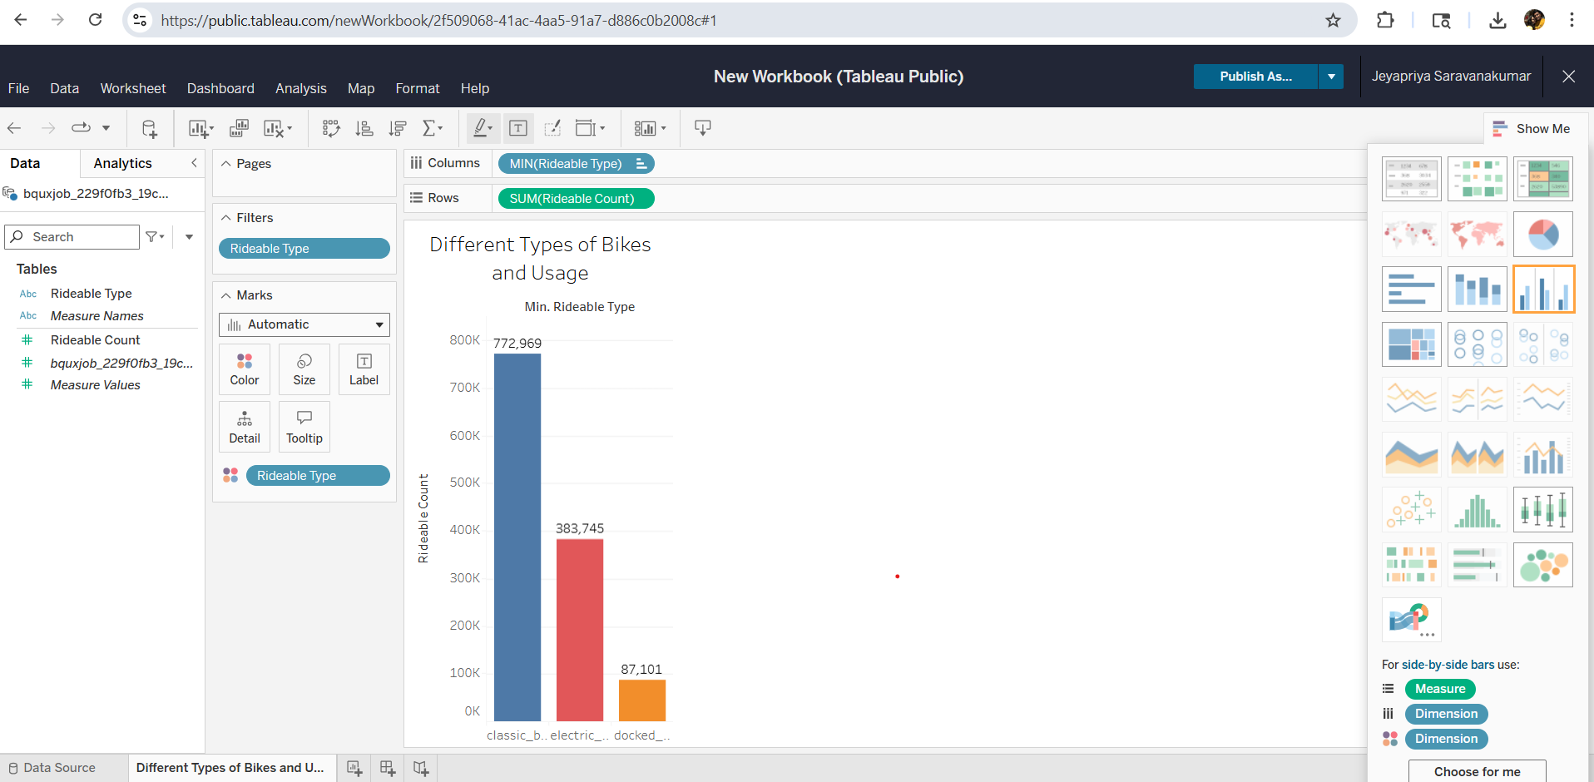

Ride Day:
Below is a Tableau screenshot showing the differences between weekdays and weekends for casual and members. On weekdays, members' rides are higher than casual rides. Weekend casual rides are a little higher than member rides.

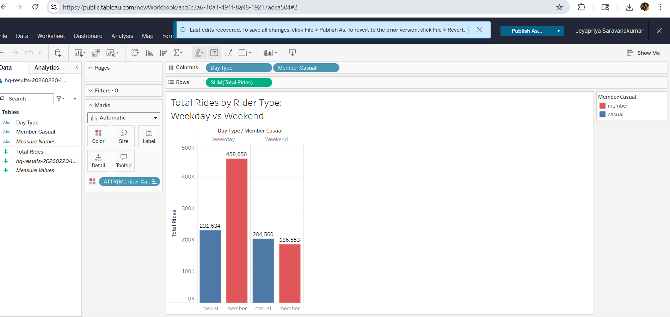
Ride Length:
The table below shows ride lengths in hours, days, weeks, and months for casual and member rides.
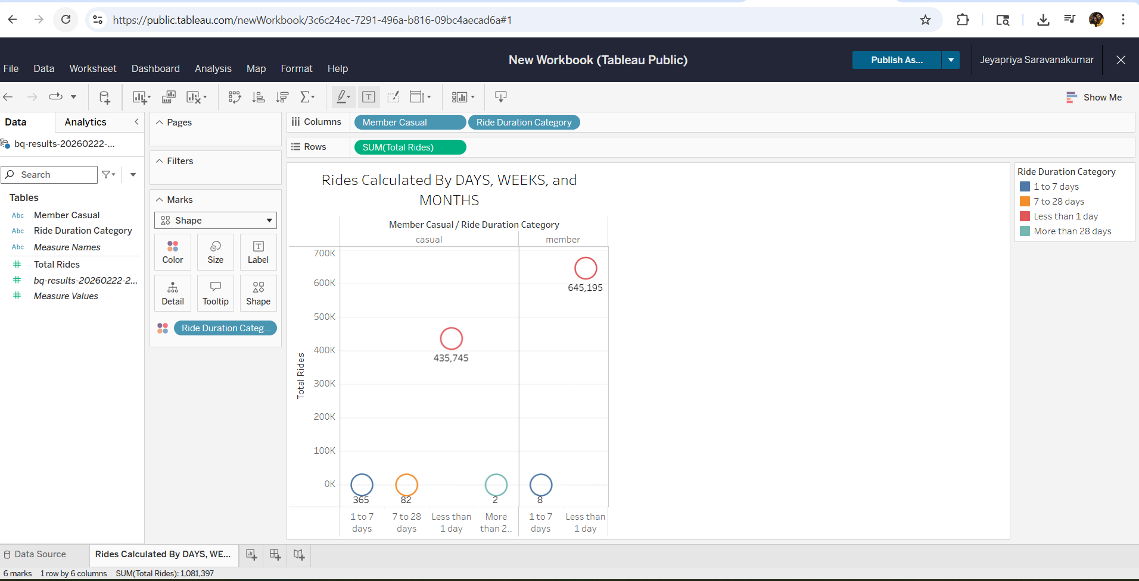
- Act – Recommendations:
I have analyzed the bike-share data from (202101 – 202105) across different categories. I analyze two different ride types: Casual and Member. Casual riders are those who do not have a membership, while membership riders have one. I checked the non-null values for the start station ID and end station ID to count membership and casual riders. Membership riders (645203) are higher than the Casual riders (436194). Then I analyze the bike types: Classic bike = 772969, Electric bike = 383745, Docked bike = 87101. Classic and electric bike usage is higher than that of other bikes. If you increase the bike count for those two types, you could boost company revenue. Then I explore the difference between weekdays and weekends. Membership rides are higher on weekdays, and casual rides are slightly higher than membership rides on weekends. Finally, I analyze the casual and membership riders by day, week, and month. People who ride bikes less than once a day are higher in both categories, and those who have been riding for more than 28 days are very low. Overall, membership riders are higher than casual riders, and there is a need to convert casual riders to membership riders. Announce discounts to casual riders, increase classic and electric bikes to help increase membership riders, and get new riders.

